

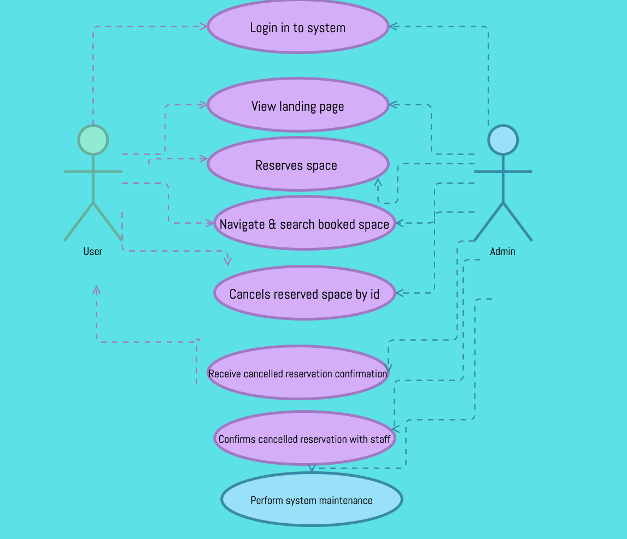

|  |  |
| --- | --- |
| Hot Desk Cancellation Use Case |  |
| Description | Give users who have booked a meeting room the functionality to cancel. |
| Actors | Staff & administrators |
| Pre-conditions | User must have logged an existing booking confirmation of meeting room. (ref number/id) |
| Trigger | Need to cancel reservation |
| Main Flow of Events | Login & navigate system, view existing reservations, select reservation to be cancelled, process cancellation & receive confirmation. |
| Alternate flow | Login & navigate system, unable to locate reservation space/ system error. Unable to cancel reservation |
| Post Condition | Reservation is cancelled space is now available for others to book & user receives cancellation confirmation |
| Issues | System issues resulting in cancellation not processing, space remains reserved and others cannot book this utility, system not correctly updated. |